Laboratory Project Report

On

Vehicle Dynamics and Powertrain Performance of an ATV

BY

J Chaitanya Sree Krishna (2021A4PS2273H)

Under the supervision of

Prof. N Suresh Kumar Reddy.



**SUBMITTED IN PARTIAL FULFILLMENT OF THE REQUIREMENTS OF ME F366: LABORATORY PROJECT**

**BIRLA INSTITUTE OF TECHNOLOGY AND SCIENCE PILANI**

**HYDERABAD CAMPUS**

Table of Contents

**1.ABSTRACT3**

**2.ROLL-CAGE ANALYSIS 4**

2.1 Objective 4

2.2 Material Properties4

2.3 Analysis Process 4

2.3.1 Front Impact 5

2.3.2 Side Impact 5

2.3.3 Rollover 6

2.3.4 Rear Impact 7

2.3.5 Bump Test 7

**3.POWERTRAIN9**

3.1 Objective 9

3.2 Material Properties9

3.3 Analyzing Process9

3.4 Powertrain Vehicle Dynamics10

**4. SUSPENSION 12**

4.1 Objective12

4.2 Material Properties 12

4.3 Analysis Process 12

4.3.1 Calculation Method 13

4.3.2 Boundary Conditions for Knuckle 13

4.3.3 Boundary Conditions for Control Arms 14

**5. BRAKING 15**

5.1 Objective15

5.2 Material Properties 15

5.2 Analysis Process 15

**6. Manufacturing Phase 15**

6.1 Manufacturing Processes Adopted18

6.2 Roll-Cage 19

6.3 Suspension & Steering 22

6.4 DFMEA Reports 26

**7. Inferences29**

**8. Conclusions30**

1. ABSTRACT

The aim of this project is to design, simulate, and manufacture an ATV meeting the requirements of the BAJA SAEINDIA rulebook. Through thorough research, analysis, and learning, we constantly implement new ideas and innovate. Considering both the functionality of the vehicle and the competition requirements. Our objective is to achieve drivers’ safety, be rugged, easy to manufacture, cost efficiency, maintain weight to performance efficiency, and test it to optimize further. This report contains documentation of the techniques followed for research, design drafting, testing, simulation, analyzing, and optimizing them to create a database for the selection and design of various components of the vehicle: roll cage, powertrain, brakes, steering, and suspension. Considering the design to be dependable, cost-effective, modular, ergonomic, and repairable. The vehicle is an integration of subsystems divided into design, powertrain, suspension, steering, and braking. These subsystems are individually based on their respective principles and objectives, which come together to form a single entity

1. Roll-cage analysis

2.1 Objective

The chassis of the car was created to minimize weight and manufacturing complexity while maximizing driver safety, vehicle strength, and longevity. Using CAE, the structure was examined and geometrically optimized using CAD and simulation software.

-For testing safety parameters and structural integrity by calculating Structural stress FOS, Total deformation, Maximum stress, and life.

2.2 Material properties

Taking into account the material's durability, affordability, availability, and manufacturability AISI 4130 was used to construct a reliable rollcage.

Properties of AISI 4130:

|  |  |  |  |
| --- | --- | --- | --- |
| **Density** | 7850 kg m^-3 | **Tensile yield strength** | 460 MPa |
| **Young's modulus** | 2000 GPa | **Tensile ultimate strength** | 560 MPa |
| **Poisson ratio** | 0.285 | **Machinability** | ~70-72% |
| **Bulk modulus** | 1550.4 GPa | **Thermal conductivity** | 42.7 W/mK |
| **Shear modulus** | 778 GPa |  |  |

-Considering linear material model for analysis.

2.3 Analysis processes

## -Finite element analysis

Linear static structural analysis was carried out with border circumstances to represent collision conditions on a rigid wall. The CAD model was loaded into the analysis software, and unwanted edges and surfaces were refined and corrected using the appropriate tools for seamless meshing. For meshing, we used a 3D tetrahedron element type with an element size of 10 mm, producing 251732 elements and 503247 nodes; with program-controlled quadratic order. To maintain mesh quality, aggressive mechanical error limits are used. Bonded connection type was used for combining the individual members.

# Load cases:

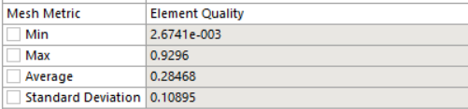 Element quality:

The mesh element quality ranges from 0 to 1, with 1 denoting a perfectly regular element and 0 denoting the element is degenerated.

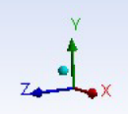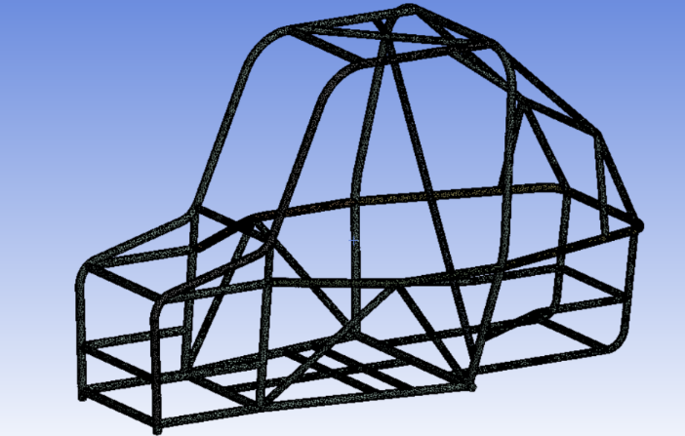

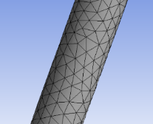

Surface view mesh

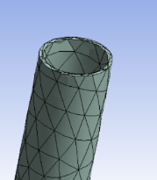

Cross-sectional view mesh

2.3.1 Front impact

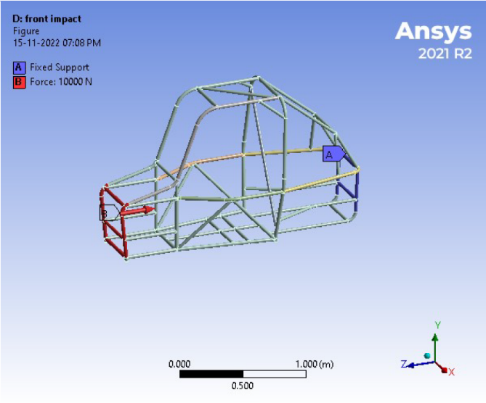Boundary condition: For simulating front impact, Force is applied on the front, keeping the rear fixed.

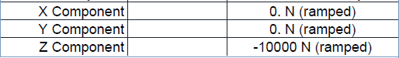Force applied:

* FOS: 1.349
* Life: 4719.2 cycles (avg)

Maximum stress: Maximum deformation:

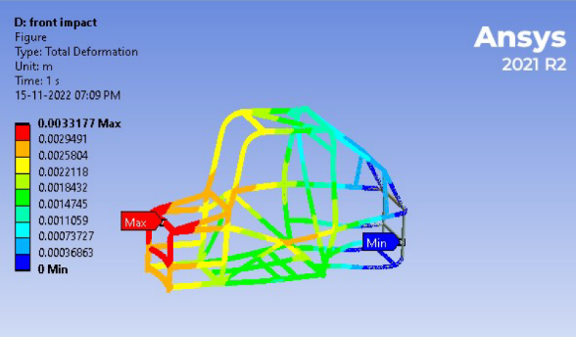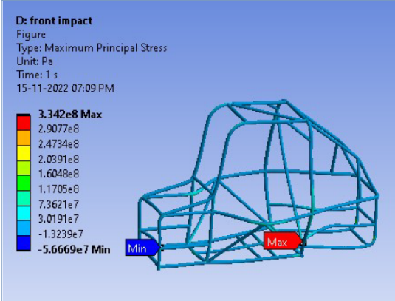

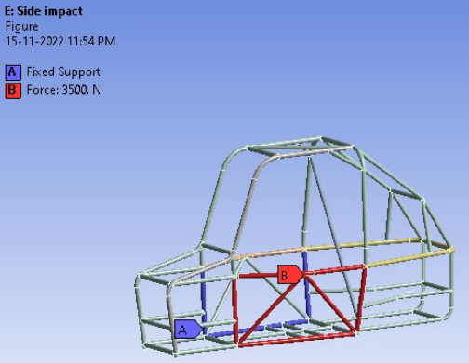 2.3.2 Side Impact

Boundary condition: For simulating side impact, force is applied on one side, keeping the other side fixed.

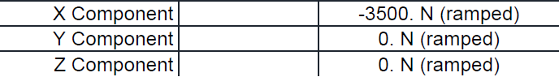Force applied:

* FOS: 0.91
* Life: 9279.3 cycles (avg)

Maximum stress: Maximum deformation:

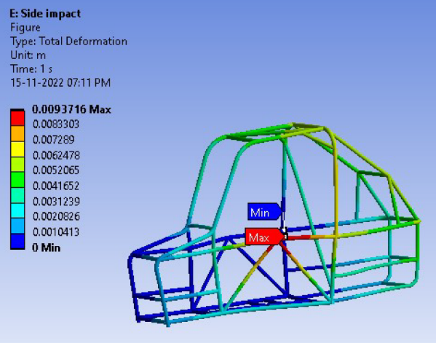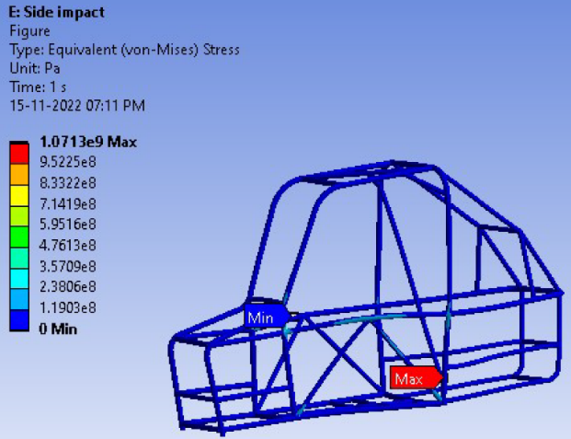

2.3.3 Rollover

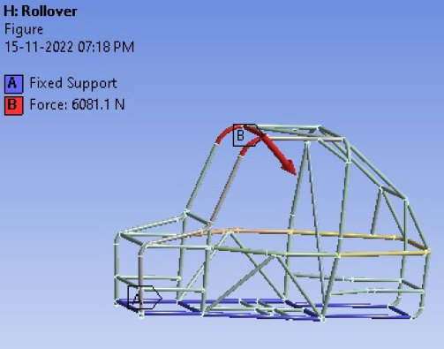Boundary condition: For simulating a rollover, force is applied on the top, fixing the base of the vehicle.

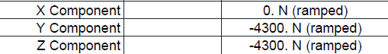Force applied:

* FOS: 1.039
* Life: 20982 cycles (avg)

Maximum stress: Maximum deformation:

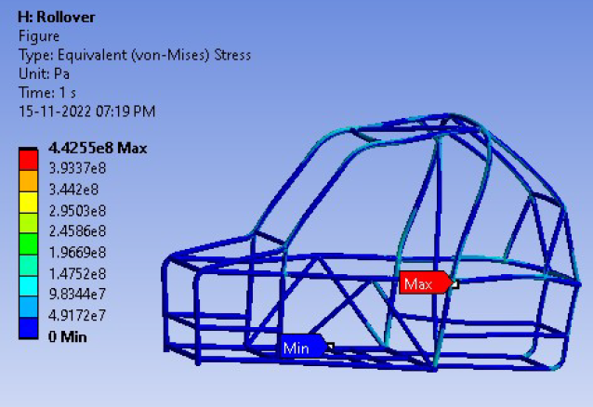 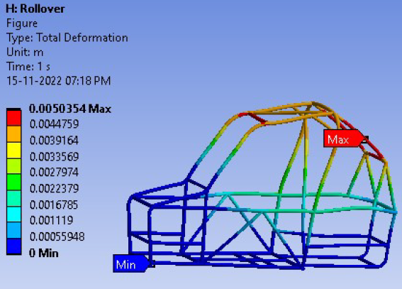

2.3.4 Rear impact

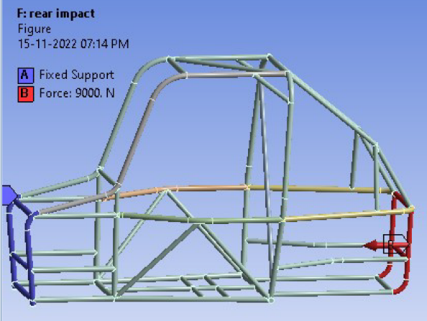Boundary condition: Force is applied to the back of the roll cage while keeping the front stationery to simulate a rear crash.

Force applied:

* FOS: 1.0081
* Life: 6406.2 cycles (avg)

Maximum stress: Maximum deformation:

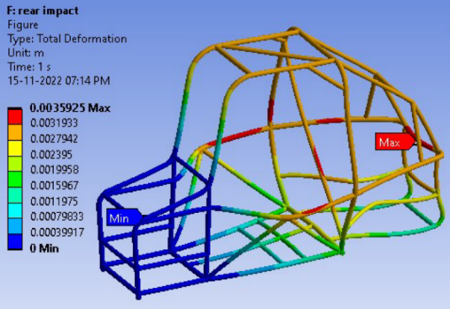 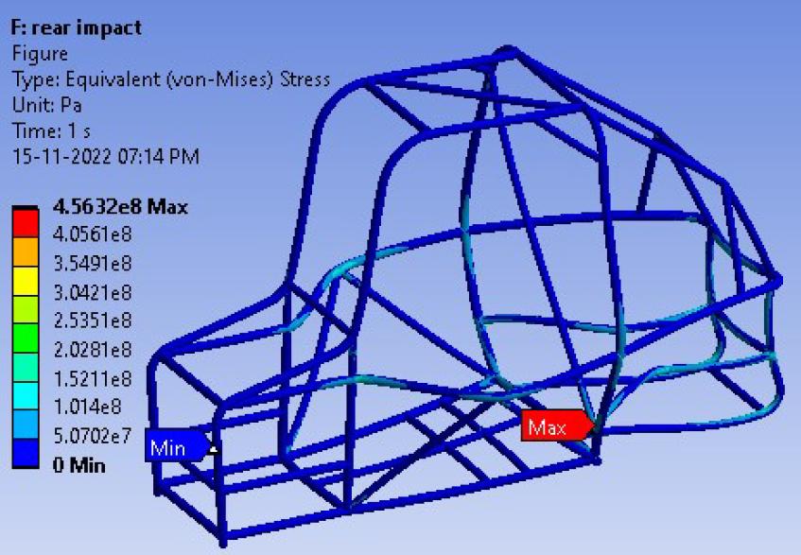

2.3.5 Bump test (roll-cage torsion)

Boundary condition: bumps are simulated by applying forces at the connection members of control arms.

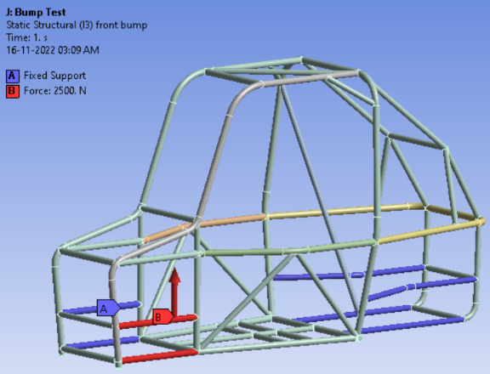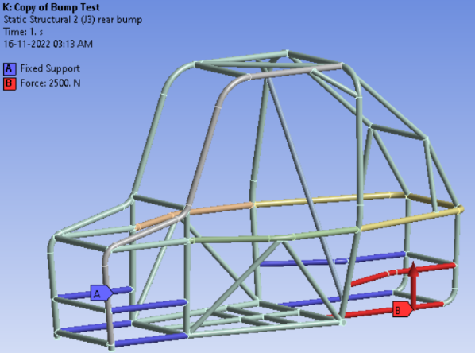 Front bump Rear bump

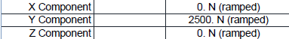Force applied:

* FOS: 1.9 FOS:1.627
* Life: 11972 cycles (avg) Life:8826.7 cycles (avg)

-Maximum stress: -Maximum deformation:

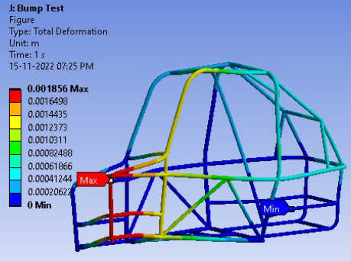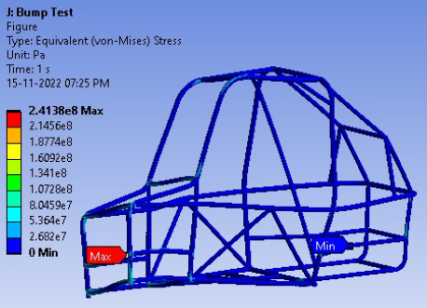

* The rollcage is structurally intact as the FOS are around 1.

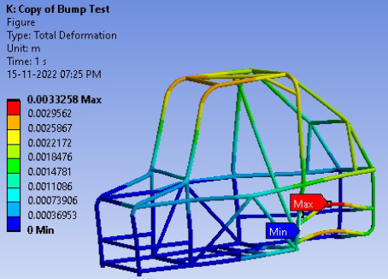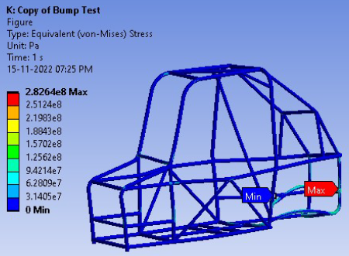

3.Powertrain

3.1 Objective

To find Factor of Safety (FoS) shown by gearbox shafts under loads applied by gears and bearings, and hence determine possible failure in the shafts.

3.2 Material properties

Material chosen for shafts is AISI 1045, with given below mentioned structural properties.

|  |  |  |  |
| --- | --- | --- | --- |
| **Density** | 7870 kg m^-3 | **Tensile yield strength** | 310 MPa |
| **Young's modulus** | 200 GPa | **Tensile ultimate strength** | 650 MPa |
| **Poisson ratio** | 0.29 | **Bulk modulus** | 158.73 GPa |
| **Shear modulus** | 775.19 GPa |  |  |

-Considering linear material model for analysis.

3.3 Analysis processes

## -Finite element analysis

Finite Element Analysis was used to determine the minimum Factor of Safety, maximum deformation, and maximum equivalent stress by applying necessary boundary conditions. For meshing, the automatic meshing method was used with element size 9.6047e-003m~10mm, resulting in 3739 nodes and 1700 elements. Refinement was also added to obtain uniform nodes throughout the shaft for more accurate results. Aggressive mechanical error limits were used to maintain mesh quality.

## -Boundary conditions:

The 2-stage reduction Gearbox consists of 3 shafts, excluding input shaft from CVT. In all 3 shafts, appropriate moments were applied on the band corresponding to the gear which receives power. Frictionless supports were applied on bands corresponding to the bearings. Fixed supports were applied on bands assuming movement of corresponding shaft/wheel is restricted.

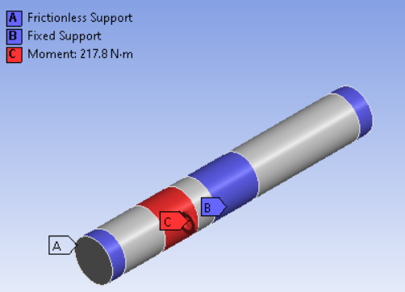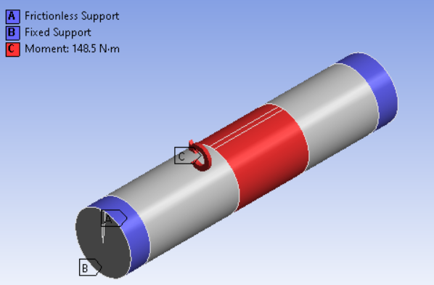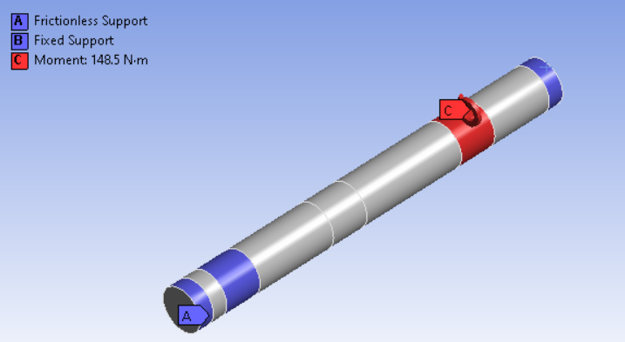

1st stage 2nd stage (rear) 2nd stage (front)

### -Maximum deformation: ( Maximum Deformation is in the order of 10e-4 and 10e-5, which is negligible)

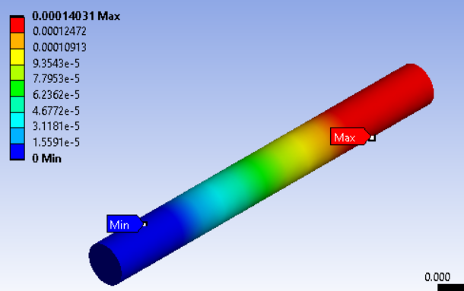

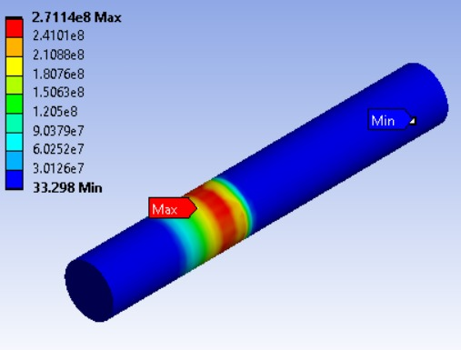-Maximum stress: (All obtained max stress values are below the yield strength of 310MPa.) 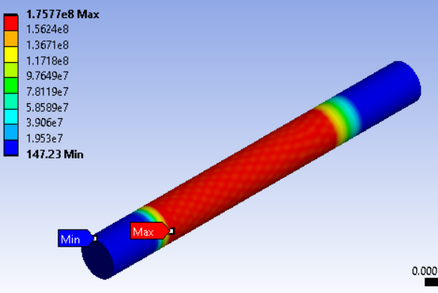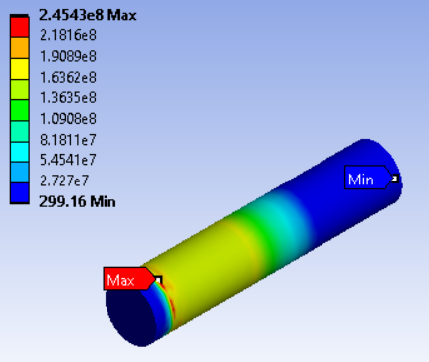

FOS: 1.76 1.26 1.14

### .

3.4 Powertrain vehicle dynamics

The entire powertrain of our vehicle has been modelled in Simulink using basic equations obtained from the dynamic model of the drivetrain. The inputs to this model are the engine rpm corresponding to the input throttle and steering angle. The outputs obtained from this model are the vehicle acceleration, velocity, and the wheel rpm of all four wheels. Some highlights of the model are the CVT block, 2-stage reduction gearbox and the rack travel block, through which turn radius and angles turned by the wheels during steering can be found. These relations have been obtained from the Adams simulation for the suspension analysis of the vehicle.

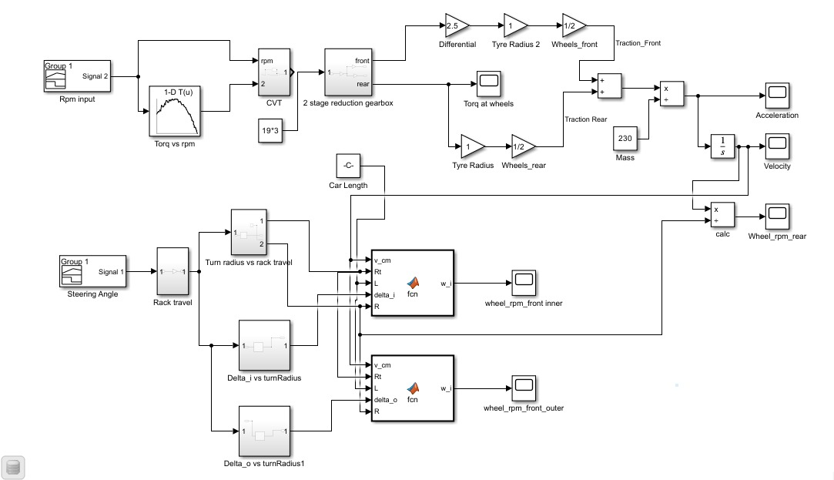

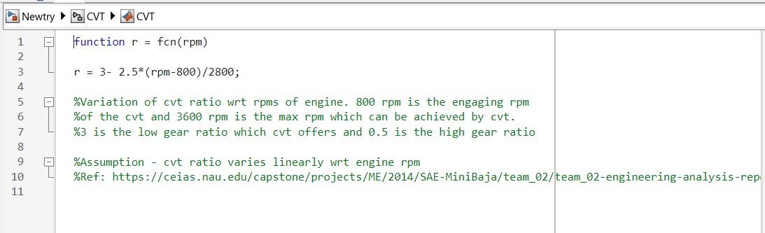The CVT block:

The CVT has been modelled considering that the CVT ratio varies linearly with engine rpm. The CVT's engaging rpm and maximum rpm are 800 rpm and 3600 rpm, respectively. 3 and 0.5 are the CVT's corresponding low gear and high gear ratios, respectively.

The reduction gearbox block has been modelled to provide different reduction ratios to the front and rear axles of the vehicle. The overall gear ratio for the front axle is 4.88 and for the rear axle is 11.96.

4. Suspension

4.1 Objective

This year our main objective of suspension geometry was to accommodate the front drive shaft by attaching a damper to the upper wishbone in front and have three-link rigid H arms support suspensions for the rear, which will help the vehicle have a smoother ride and driver comfort at complicated maneuvers. Using CAE, we get to know factor of safety of different components of the suspension system.

4.2 Material properties

-**Knuckle**

The material chosen for shafts is Al 7075-t6, with structural properties as following:

|  |  |  |  |
| --- | --- | --- | --- |
| **Density** | 2810 kg m^-3 | **Tensile yield strength** | 503 MPa |
| **Young's modulus** | 71.7 GPa | **Tensile ultimate strength** | 572 MPa |
| **Poisson ratio** | 0.33 | **Thermal conductivity** | 130-150 W/mK |
| **Shear modulus** | 26.9 GPa |  |  |

-Considering linear material model for analysis.

- **Control arms**

The material chosen for control arms is AISI 4130.(mentioned on page number. 1)

4.3 Analysis processes

## -Finite element analysis

**Front Knuckle:** The cae processes involved the use of tetrahedron elements for meshing throughout the component, with an element size of 10 mm, and quality of 0.63. The element arrangement followed a quadratic order, with the component bolted to the main vehicle body. A linear model was considered for component analysis

**Rear Knuckle**: Usage of tetrahedron elements was employed in the meshing of the component, with an element size of 10 mm. The element arrangement followed a quadratic order, with the component bolted to the main body of the vehicle.

**UCA(upper control arm)**: Tetrahedron elements were used for carrying out meshing for component analysis, with an element size of 9 mm, and quality of 0.35. The element arrangement followed a quadratic order, with the component bolted to the main vehicle body.

**LCA(lower control arm):** The cae processes involved the use of tetrahedron elements were used for carrying out meshing for component analysis, with an element size of 1cm, and quality of 0.31. The element arrangement followed a quadratic order, with the component bolted to the main vehicle body.

**H-arms Upper Link:** Tetrahedron elements were used for carrying out meshing for component analysis, with an element size of 1cm, and quality of 0.31. The element arrangement followed a quadratic order, with the component bolted to the main body vehicle.

**H-arms Lower arms:** Usage of tetrahedron elements was employed in the meshing for component analysis, with an element size of 1 cm, and quality of 0.31. The element arrangement followed a quadratic order, with the component bolted to the main body vehicle.

-A linear model was considered for component analysis

## 4.3.1 Calculation method:

**Control arms:**  Load calculations were performed in ADAMS via static load simulation. Using ADAMS, the front and rear suspensions had to be manually adjusted as ADAMS doesn't provide a preset template for the suspension designs. The front module was changed via template mode to shift the knuckle onto the upper wishbone. The rear module required more customization since the system of choice was an H-arm suspension with lateral single links.

The various steering loads, namely:

|  |  |  |  |  |
| --- | --- | --- | --- | --- |
| **Load** | **Front left** | **Front right** | **Rear Left** | **Rear Right** |
| **Aligning torque** | 50 | 50 | 50 | 50 |
| **Braking force** | 1163.097 | 1163.097 | 1163.097 | 1163.097 |
| **Cornering force** | 1764.31 | 1764.31 | 1764.31 | 1764.31 |
| **Traction force** | 435.47 | 435.47 | 435.47 | 435.47 |

|  |  |
| --- | --- |
| **Properties** | **Input** |
| C.G. Height | 30 inches |
| Tire unloaded radius | 265 mm |
| Wheel mass | 200 units |
| Tire stiffness | 10 kg |
| Vehicle sprung mass | 310 kg (with driver) |

Forces were calculated considering the above parameters in the ADAMS software.

4.3.2 Boundary conditions (for knuckle):

Point of load application based on the structural configuration of the component.

Front Knuckle Rear knuckle

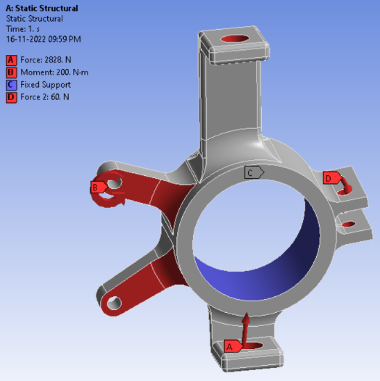 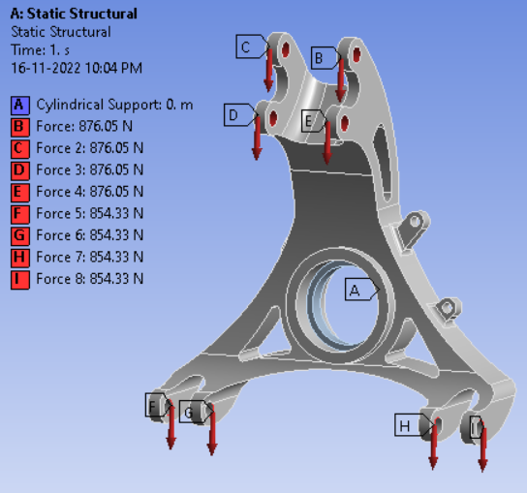

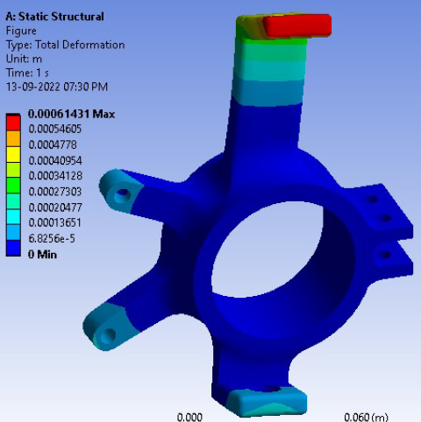-Maximum deformation:

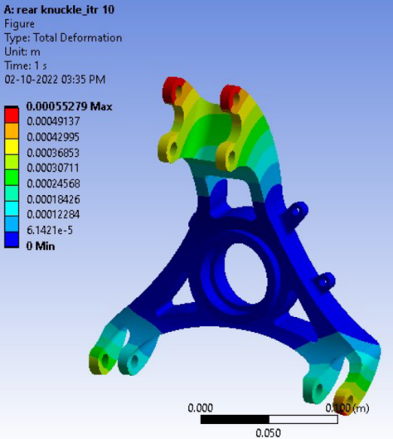

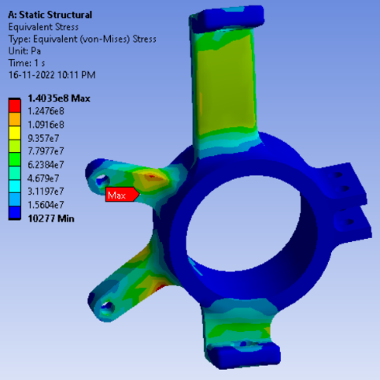 -Maximum stress:

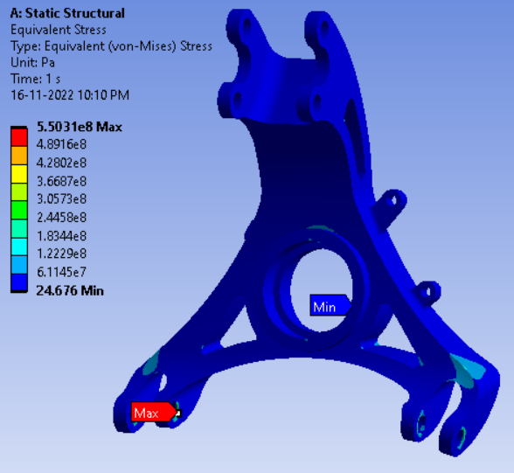

* FOS: 1.84 2.69

4.3.3 Boundary conditions (for Control arms):

Point of load application based on the structural configuration of the component.

Maximum deformation:

H-arms Upper Link

UCA

H-arms Lower arms

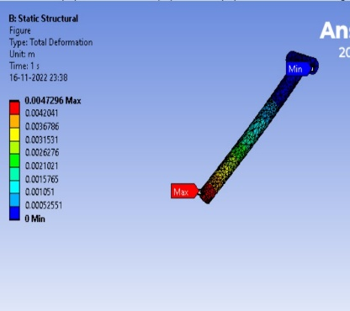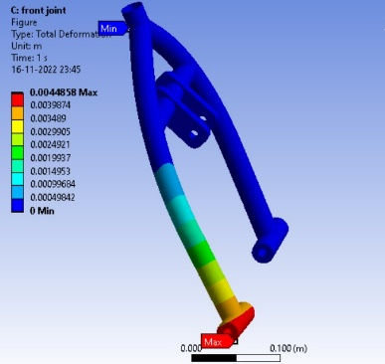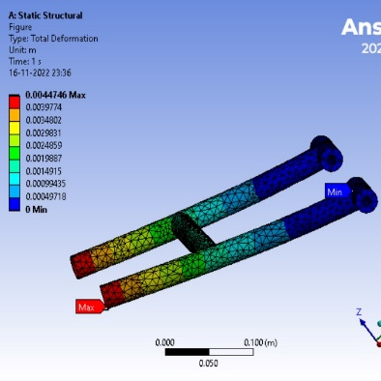

-Maximum stress:

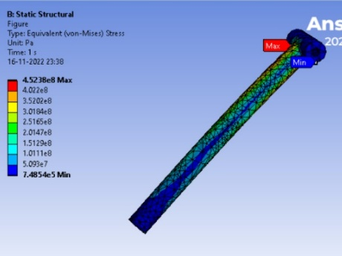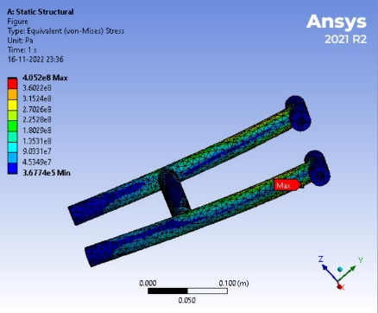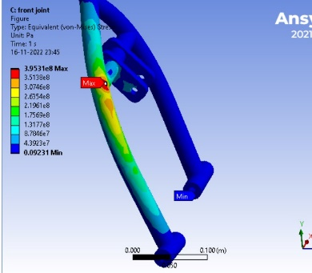

FOS: 1.14 1.02 1.58

5. Braking Analysis

5.1 Objective

This year’s Braking model was designed to reduce the stopping distance considerably. Diagonal braking split is used to ensure failsafe.

5.2 Material properties

Taking into account the material's durability, affordability, availability, and manufacturability AISI 4130 was used to construct a reliable rollcage.

Front axle force: 9098.8 N, rear axle force: 6065.9 N , Braking pad area: 1182.892 mm^2, Stress on front axle : 7.69 N/mm^2 = 7.69 Mpa and stress on rear axle: 5.13 N/mm^2 = 5.13 Mpa

|  |  |  |  |  |  |
| --- | --- | --- | --- | --- | --- |
| **Properties** | **Aluminium 7075T6** | **Grey Cast Iron** | **Stainless steel 410** | **Ti-alloy(Ti-6Al-4V)(Grade 5)** |  |
| **Young's modulus(Gpa)** | 71.7 | 118 | 200 | 114 | SS 410 |
| **Strain(Front axle)(mm)** | 0.107 | 0.0652 | 0.03845 | 0.0674 | SS 410 |
| **Strain(Rear axle)(mm)** | 0.0715 | 0.0435 | 0.02565 | 0.045 | SS 410 |
| **Ultimate tensile Strength(Mpa)** | 572 | 700 | 1400 | 950 | SS 410 |
| **Yield Strength(Mpa)** | 503 | 420 | 1076 | 880 | SS 410 |
| **Density(g/cc)** | 3 | 7.2 | 7.74 | 4.43 | Al 7075T6 |
| **Elongation at break(fracture strain)(%)** | 7.9 | 15 | 14.5 | 14 | Al 7075T6 |
| **Hardness, Vickers** | 175 | 235 | 446 | 349 | SS 410 |
| **Linear thermal expansion coefficient (α)(K^-1)** | 2.36*10^-5 | 5.8*10^-6 | 5.5*10^-6 | 8.6*10^-6 | SS 410 |
| **Cost(Rs./Kg)** | 486 | 60 | 355 | 1600 | GCI |

**SS 410 has more points than any other material**

5.3 Analysis processes

## Finite element analysis

Linear static structural analysis was carried out with border circumstances to represent collision conditions on a rigid wall. The CAD model was loaded into the analysis software, and unwanted edges and surfaces were refined and corrected using the appropriate tools for seamless meshing. For meshing, we used a 3D tetrahedron element type with an element size of 30 mm, producing 3332 elements and 16164 nodes; with program-controlled quadratic order. To maintain mesh quality, aggressive mechanical error limits are used. Bonded connection type was used for combining the individual members.

## Boundary Conditions

* The torque due to brake pad friction is taken as the input.
* The hub mounting points are assigned fixed constrained.

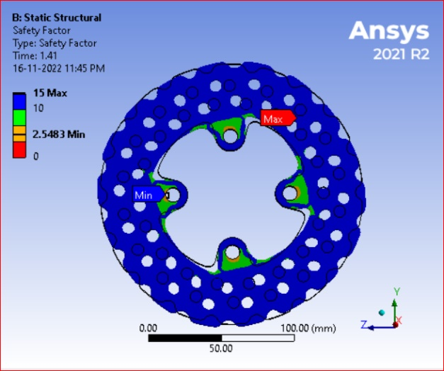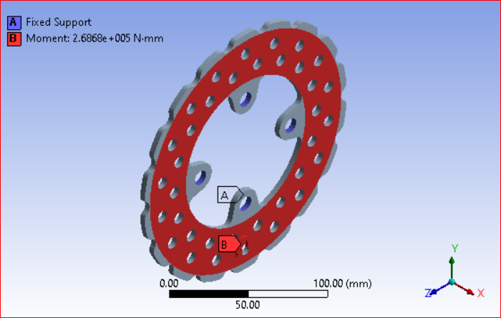FOS:2.54

Static Structural Analysis of Brake Disc Min. FOS: 2.5483

# 6.MANUFACTURING PHASE

## 6.1 Various methods:

* **CNC milling**: CNC milling is a machining process that employs computerized controls and rotating multipoint cutting tools to eliminate material from a workpiece. The CNC machine interprets the design or CAD (Computer-Aided Design) file and carries out accurate movements to produce the intended shape or features on the workpiece.
* **VMC- vertical milling machine**: Vertical milling machines, also referred to as VMCs, feature a spindle oriented in a vertical position to accommodate cutting tools. The workpiece is affixed to a table and can be maneuvered in various directions. Vertical machining centers (VMCs) are frequently employed for the precision machining of intricate components with complex geometries.
* **Lathe**: A lathe is a machine tool that rotates a workpiece around an axis of rotation to carry out different operations, such as cutting, turning, facing, and threading. The cutting implement is utilized on the workpiece to eliminate the substance and mold it into the preferred configuration.
* **CNC Plasma cutting**: CNC plasma cutting is the process of using a fast-moving stream of ionized gas (plasma) to cut through materials that can conduct electricity. The CNC system governs the motion of the plasma torch, resulting in accurate incisions on the workpiece. This technique is frequently employed for the purpose of severing metal sheets and plates.
* **Radical drilling machine**: A radial drilling machine is a drill press designed for specialized purposes. It enables the drill head to move along the radial arm, which can be adjusted in height and rotated around the column. This adaptability allows for the perforation of holes in diverse locations on expansive workpieces.
* **Additive manufacturing 3D printing**: 3D printing, also known as additive manufacturing, constructs objects by sequentially adding layers based on digital models. The process entails the sequential deposition of materials, such as plastic, metal, or resin, to fabricate a three-dimensional entity. The value of 3D printing lies in its capacity to create intricate forms and prototypes with exceptional accuracy.
* **Welding**: Welding is the process of combining multiple materials by heating them until they melt and fuse together. Different applications utilize various welding techniques, including arc welding, MIG (Metal Inert Gas) welding, and TIG (Tungsten Inert Gas) welding.
* **Thermal hardening**: Heat treatment is a process that involves carefully heating and cooling materials in order to change their mechanical properties, including hardness, strength, and toughness.

# 6.2 Roll-Cage:-

* The roll cage was designed keeping in the manufacturability like the availability of members, and feasibility of bending pipes.
* Roll cage was finalized with no further changes before starting manufacturing.
* To check manufacturability, PVC pipes were used for design validation.
* Quality of pipes was checked.
* 3D printed mounts, and wooden supports manufactured for correctness of design corresponding to the CAD model.

*Fig. 3D aligners were designed using CAD model*.

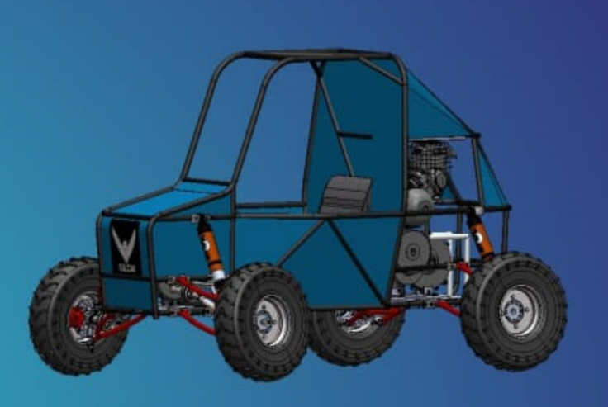

*Fig: Final roll cage model with dimensions*

## 6.2.1 Assembly of roll-

* The manufacturing was carefully done using 1:1 drawings.
* This ensured zero deviation from the designed model in CAD.

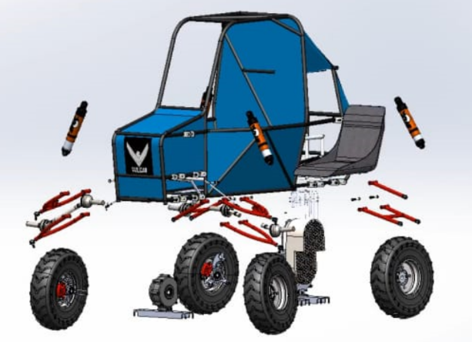

*Fig. Manufacturing of Base plate using 1:1 drawings*

*Fig: Exploded view*

*Fig: Manufacturing of wooden mounts of height 13 inches.*

This was done to ensure a safe ride height for the vehicle of 14 inches. The vertical distance between a car's body or chassis and the road is referred to as "ride height." It is an essential component of the suspension system of a car and can greatly affect the way it handles, performs, and drives in general.

## 6.2.2 Joining of Roll-cage

* The material used for roll cage members: AISI 4130
* The careful application of precision welding techniques has resulted in the effective manufacture of a sturdy roll cage. A technically sophisticated and structurally robust roll cage has been produced by construction, which complies with strict industry standards and safety laws. The application of primary welding techniques guarantees improved structural soundness, providing the assembly with greater strength and longevity.
* Welding technique, specifically arc welding followed by Tig welding, is used for joining the tubes.

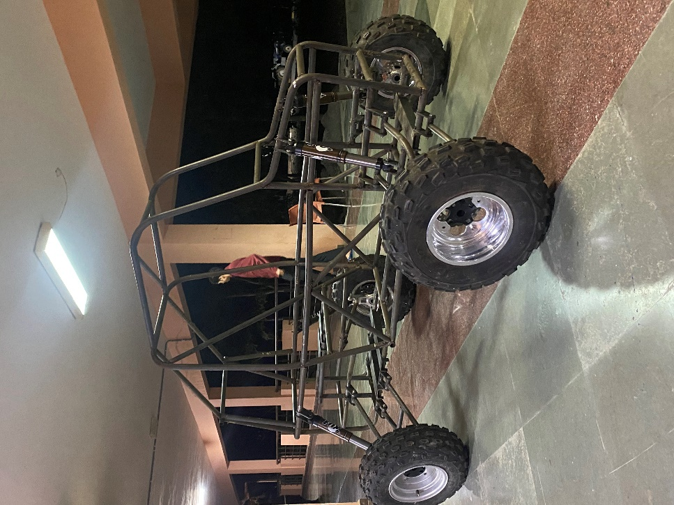

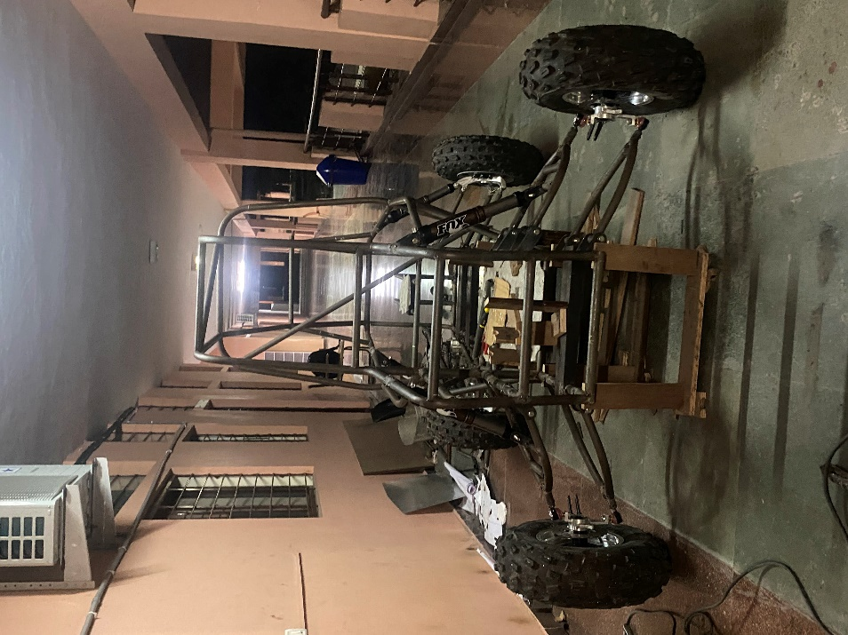

*Fig: Assembled roll cage with primary welding.*

# 6.3.1 Suspension and Steering System

Objective

* The primary objective of the suspension, steering, and braking sub-system is to provide a perfect balance between maneuverability and controllability while also keeping in mind the comfort of the driver.
* The braking subsystem had the additional job of ensuring a safe braking distance.
* Use of Lotus Shark Analysis to design the suspension systems and configure the hardpoints has been employed.
* MATLAB model was built to estimate dynamic weight transfer for braking.
* Additionally, FEA software was used to determine the maximum temperatures under braking.
* The suspension systems of choice finalized upon are: Double wishbone in the front and  an H-arm system with a single lateral upper link in the rear.

*Fig: Final design of knuckle given for manufacturing*

*Fig: Final design of knuckle given for manufacturing*

# 6.3.2 Integration of Components

* The suspension system has been designed keeping in mind the terrain of the Baja competition, and the weight and maneuverability of the vehicle.
* The double wishbone system, being lightweight and independent in nature, allows us to reduce the curb weight, along with preventing deflections during hard cornering, ensuring that the steering and the wheel alignment remain constant.
* The H-arms along with the lateral link allow for a negative camber owing to the shorter upper arm in the system. There is a positive camber gain on the outside wheel during turns when the vehicle body rolls, which is neutralized by the negative camber prevalent by the suspension arrangement, keeping the tires perpendicular to the ground.
* The suspension systems have been simulated through static load simulations in ADAMS to calculate the forces on various necessary components, that have been further used in Ansys for structural simulations of the knuckles.
* Material used for knuckles and hubs: AL 7075Ts

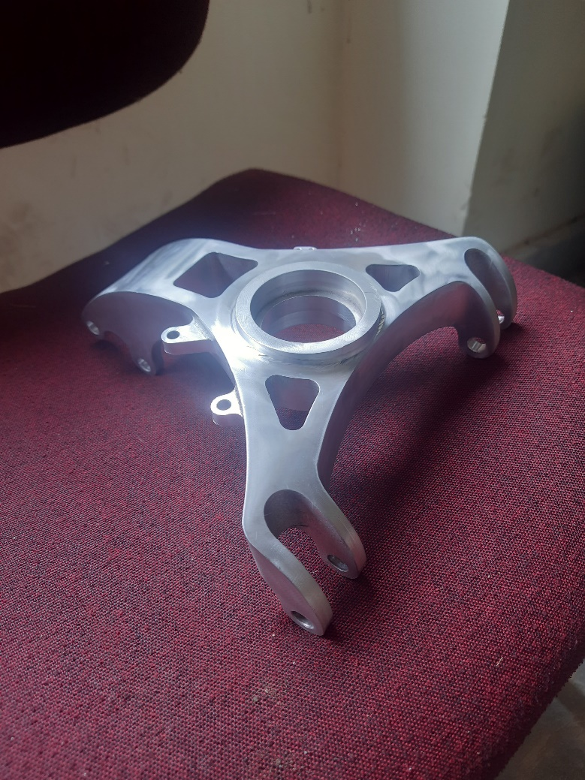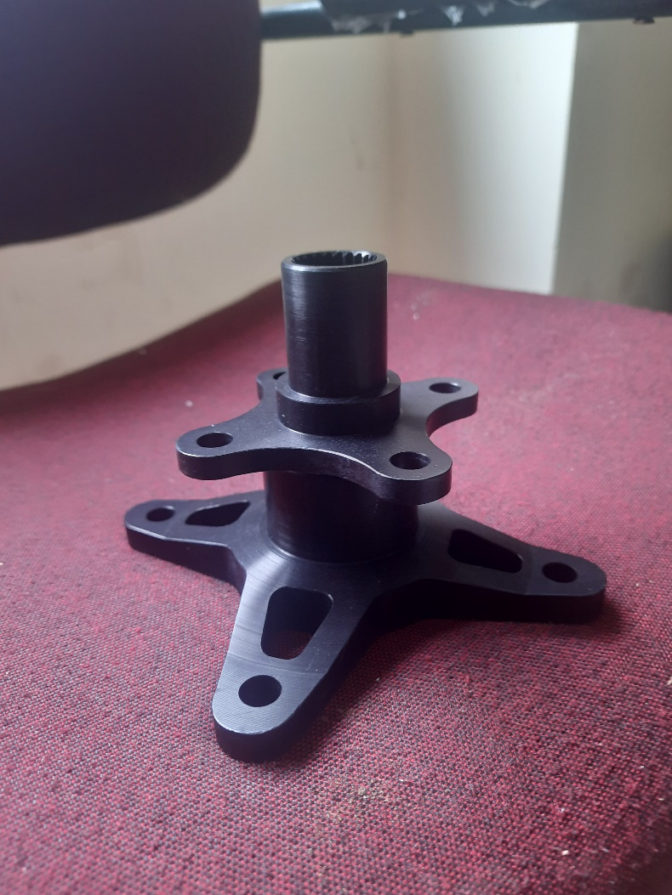

*Fig: Final machined hubs* *Fig: Final machined rear knuckle*

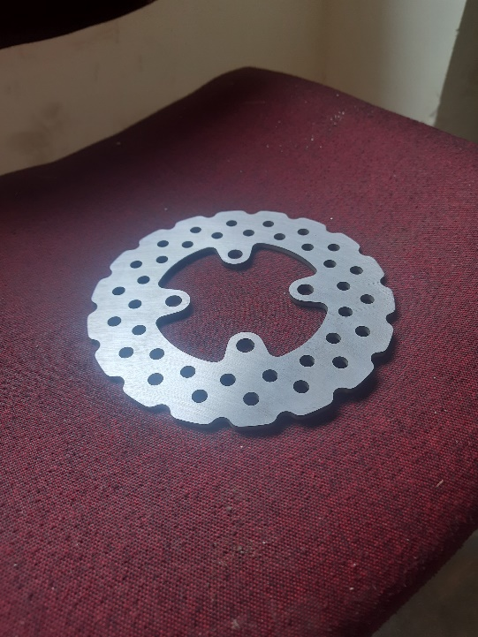

# 6.3.3 Steering

* An Ackermann steering geometry has been adopted for allowing tighter turns during low speed turning.
* A central rack and pinion arrangement has been used, with a 140mm rack travel and a 8:1 steer ratio.
* This allows focus on optimizing the camber change and minimizing the toe angle deflections during bump, droop.

*Fig: Finalized design of steering system*.

|  |  |  |  |  |  |
| --- | --- | --- | --- | --- | --- |
| Weight Distribution | 60:40 | Natural Frequency | 0.49Hz(f)  0.55Hz(r) | Ride Rate | 8.82N/mm(f)  10.56N/mm(r) |
| Trackwidth | 1277mm(f)  1145mm (r) | Roll Rate | 151.06Nm/deg(f)  229Nm/deg(r) | Wheel rate | 13.32N/mm (f)  16.28N/mm (r) |
| Motion Ratio | 1.40(f)  1.36(r) | Spring Rate | 26.11N/mm(f)  30.12N/mm(r) | Spring stiffness | 6661.98N/m(f)  8142.42N/m(r) |

*Table: Important parameters for steering design*

|  |  |  |  |
| --- | --- | --- | --- |
| Steering ratio | 8:1 | Force on tie rod | 278.5N |
| Pitch Diameter | 39mm | Total force on rack | 557N |
| Gear Modulus | 2 | Number of teeth | 19 |

*Table: Final values of the steering calculations*

|  |  |
| --- | --- |
| Camber | -1.6(f)/-1.43(r) |
| Toe | -1.52(f)/0.00(r) |
| Castor | 6.55(f)/--- |
| Kingpin Inclination | 7.12(f)/--- |

*Table: Important angles of suspension geometry*

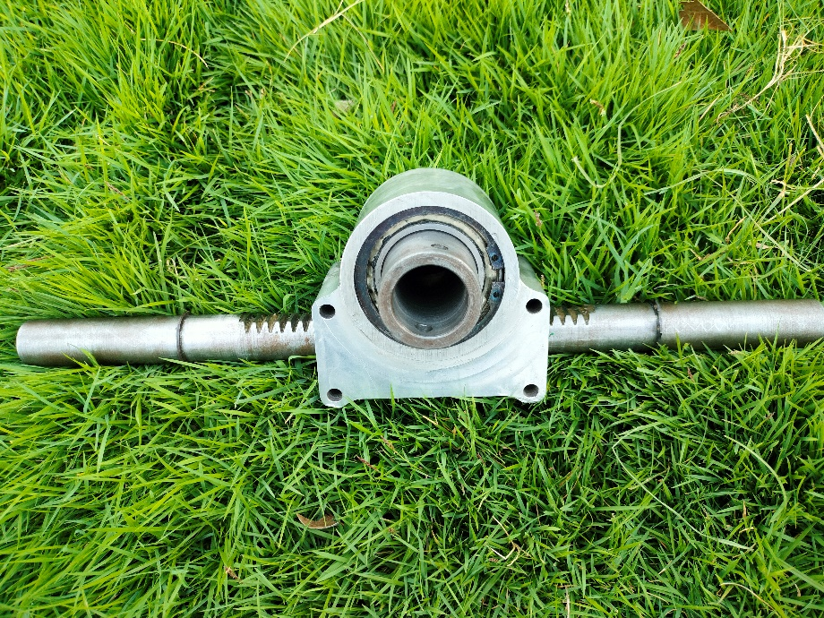

*Fig: Machined rack and pinion*

# 6.4 DFMEA reports

DFMEA stands for Design Failure Modes and Effects Analysis.. It is a methodical process for analyzing possible failure modes in a design, determining how they might affect the system or product, and coming up with countermeasures to make these failures less likely to occur. A DFMEA report's goal is to proactively find and fix any potential vulnerabilities or design flaws before they cause real product failures.

Fig: Following are the metrics used to evaluate DFMEA

1. 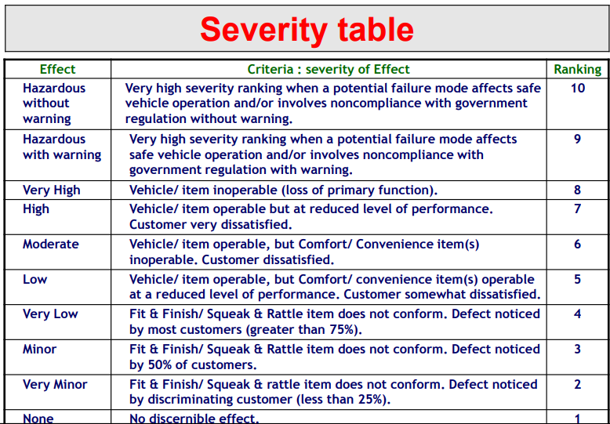Severity Table:

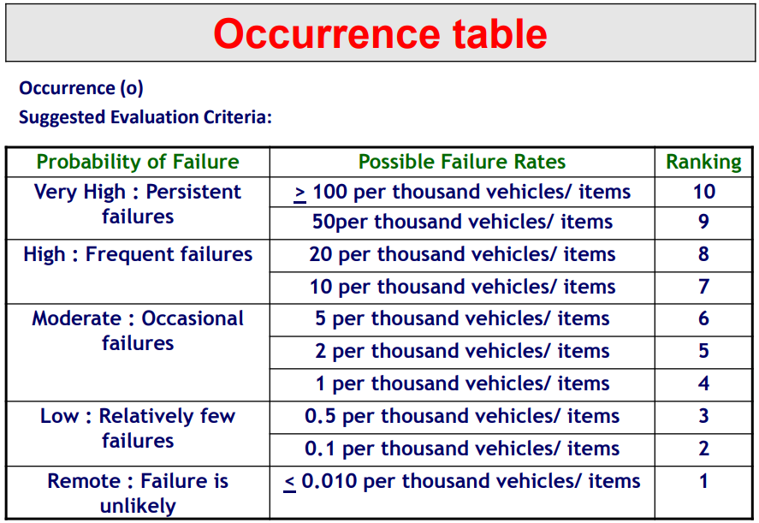

1. Occurrence Table

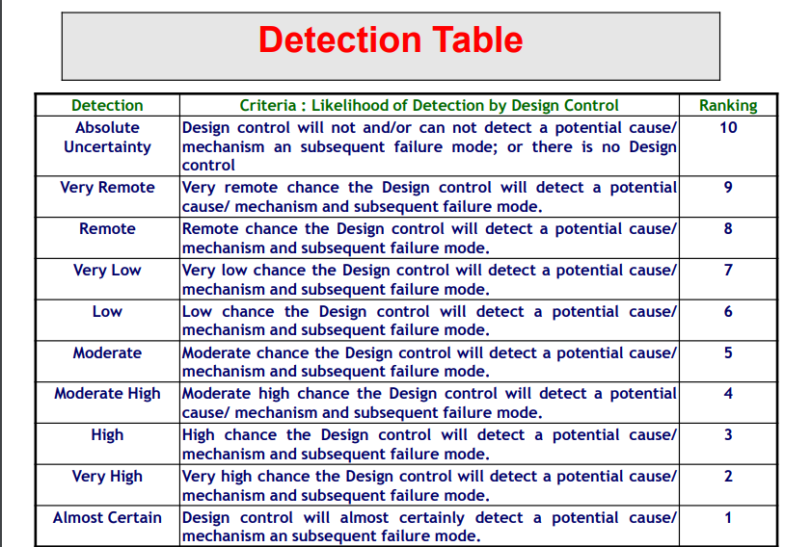

1. Detection Table

## 6.4.1 DFMEA table for Electronics

## 6.4.2 DFMEA table for Design Subsystem

## 6.4.3 DFMEA table for Powertrain Subsystem

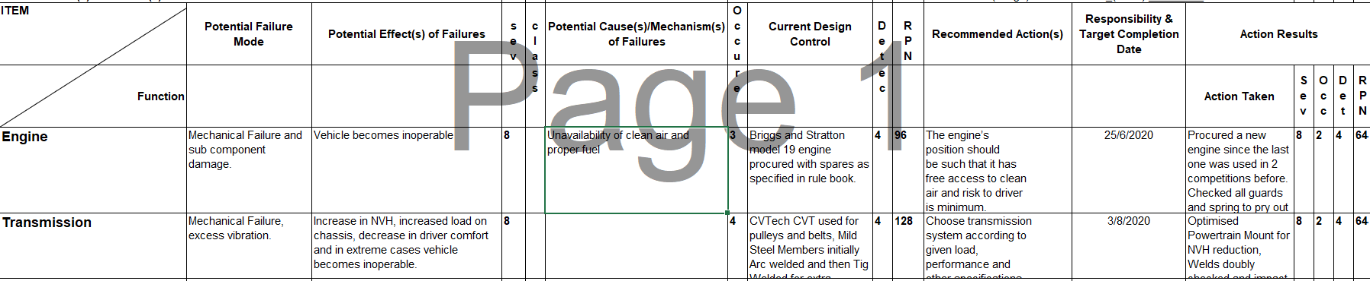

## 6.4.4 DFMEA table for Suspension and steering Subsystem

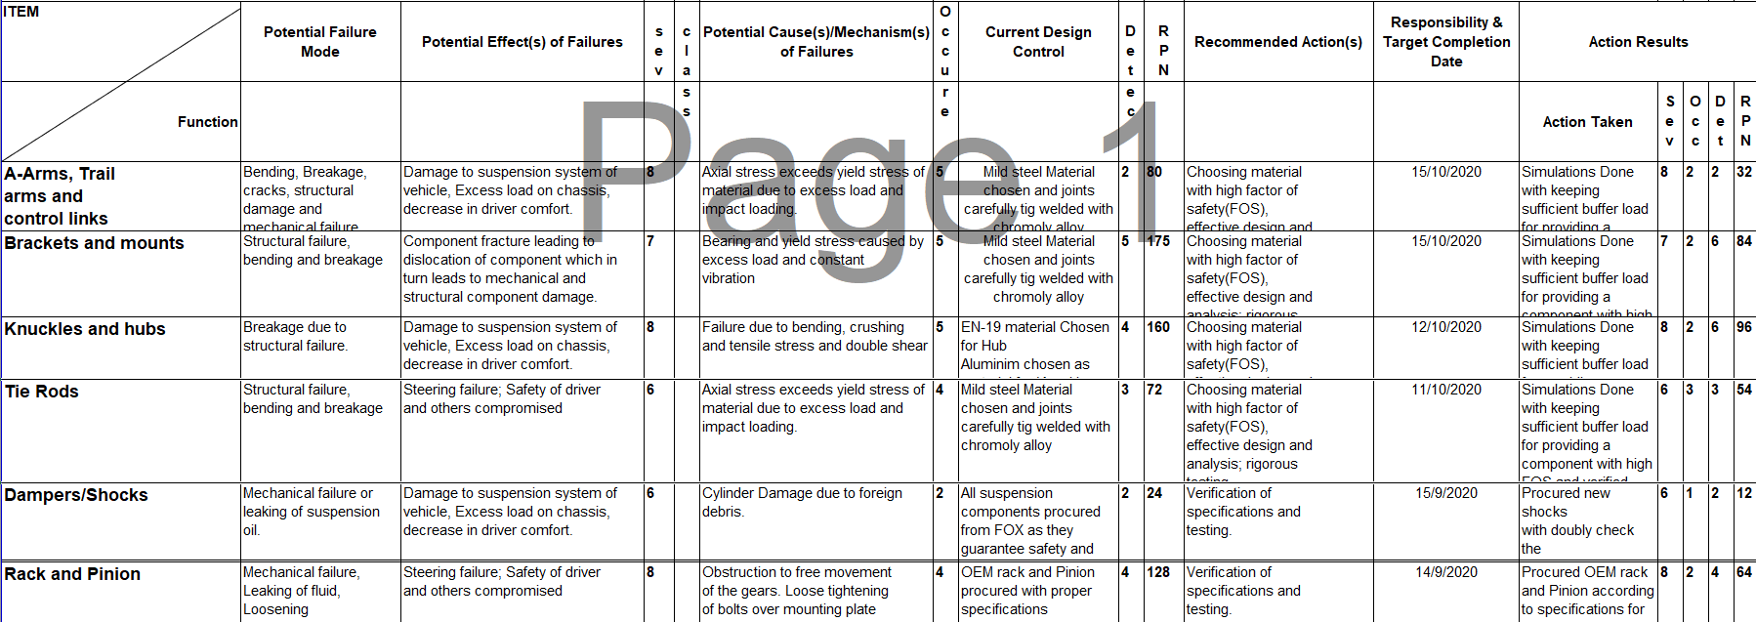

## 6.4.4 DFMEA table for Braking Subsystem

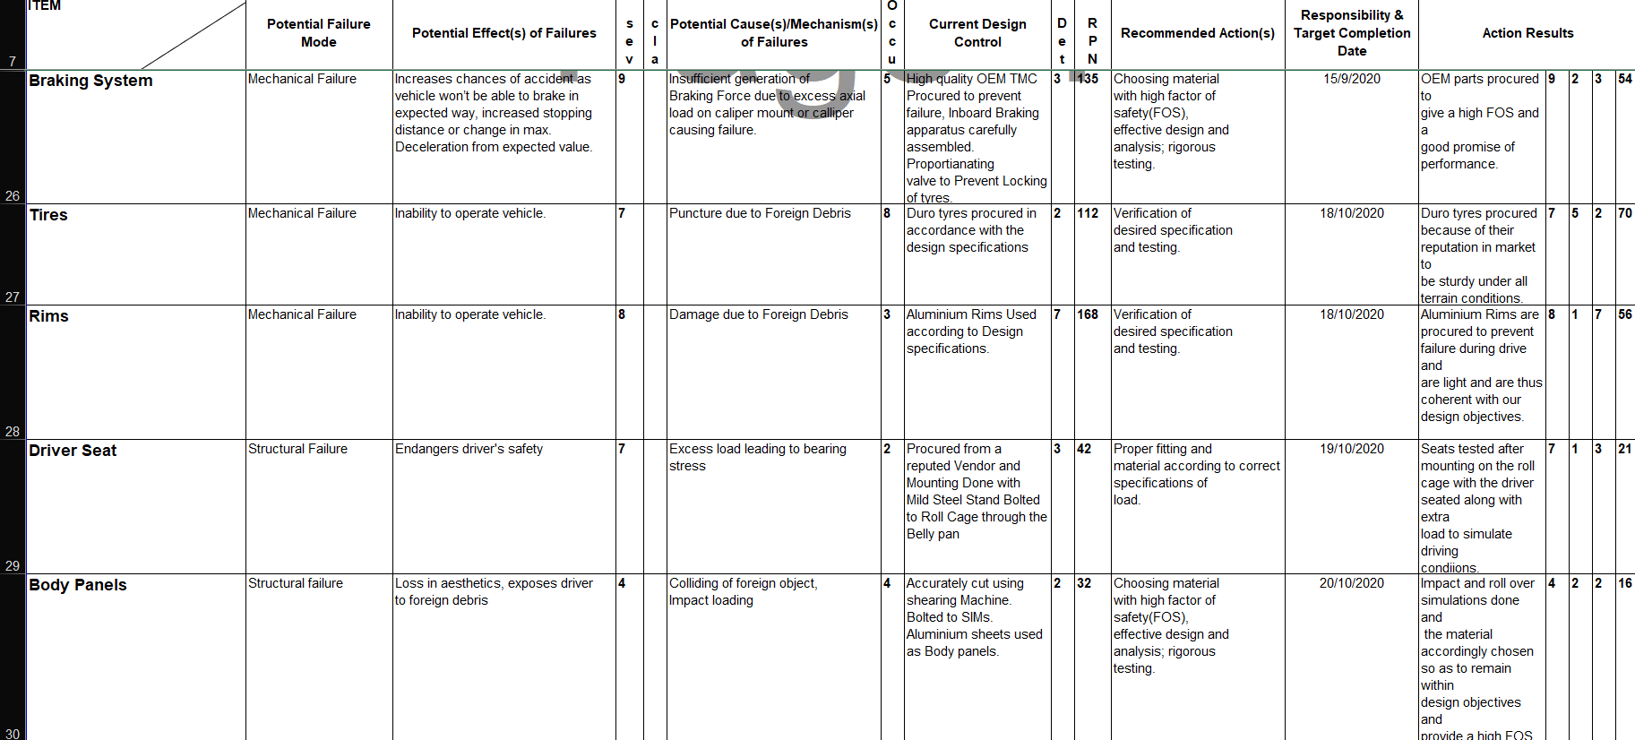

# Inference

The roll-cage analysis concentrated on enhancing the design to minimize weight and manufacturing intricacy, with a primary emphasis on safety and structural soundness. The choice of AISI 4130 Chromoly Steel for the roll cage was based on its exceptional strength-to-weight ratio, toughness, weldability, and cost-effectiveness. The roll cage's safety was verified through a series of structural analysis procedures, which involved design, modeling, and finite element analysis. These processes were carried out to assess the roll cage's ability to withstand different load conditions, such as front impact, side impact, rollover, rear impact, and bump test. The results demonstrate satisfactory factor of safety (FOS) values for various load scenarios, affirming the structural soundness of the roll cage.

The powertrain analysis aimed to ascertain the Factor of Safety (FoS) for gearbox shafts under varying loads. The material for the shafts was selected as AISI 1045 based on its favorable structural properties. The gearbox shafts were assessed using Finite Element Analysis to determine the minimum Factor of Safety, maximum deformation, and maximum equivalent stress. The results indicate that all maximum stress values obtained are below the yield strength, thus ensuring the structural integrity of the gearbox shafts.

The vehicle dynamics of the powertrain were simulated using Simulink, which included components such as the CVT block, 2-stage reduction gearbox, and rack travel block.The simulation generates results for vehicle acceleration, velocity, and wheel rpm by considering inputs such as engine rpm and steering angle.

Important conclusions about the overall performance and safety of a vehicle are drawn from the analysis of the suspension and steering subsystems Tyre wear patterns, handling dynamics, and ride comfort are all greatly impacted by the subtleties of suspension design. Through insight-based optimisation, engineers can better balance comfort and dynamic stability, improving vehicle control and safety. Analysing the steering system has a direct impact on the driver's experience by providing useful information on feel, reactivity, and accuracy. Furthermore, inferences direct the development of suspension systems that are adjustable to a variety of driving scenarios. Engineers optimise components to improve vehicle refinement and occupant comfort by addressing issues including noise, vibration, and harshness.

Braking is an essential part of car performance and safety; it helps keep you safe from accidents and maintain control in a variety of driving situations. In order to safely reduce a vehicle's speed, maintain the proper stopping distance, and avoid collisions, effective braking systems are crucial. Beyond just ensuring safety, braking improves the overall driving experience by offering steady and responsive stopping force. A vehicle's stability is enhanced by properly operating brakes, particularly when executing emergency manoeuvres. For driver confidence and the safety of passengers and other road users, a dependable braking system is essential, whether driving through cities or travelling at high speeds on highways. Braking systems are essential to the overall effectiveness and dependability of the driving experience since they also have a direct impact on other vehicle components' lifespan and fuel efficiency.

# Conclusion

The project effectively tackles the intricate design and simulation obstacles linked to the creation of an All-Terrain Vehicle (ATV), while satisfying safety, durability, and performance criteria.

The project's overall success is influenced by the careful selection of suitable materials, thorough structural analysis, and strict adherence to manufacturing best practices.The subsequent stages encompass the verification and examination procedures aimed at guaranteeing the practical functionality and security of the ATV, as indicated in the report.

In summary, the AWD ATV vehicle's manufacturing process is a thorough and complex endeavour that calls for careful planning, precise engineering, and stringent quality control procedures. We effectively developed a sturdy and high-performance off-road vehicle designed for difficult terrains by fusing cutting-edge technology with creative production techniques. Continuous improvement, safety requirements, and industry standards are all committed to, and this is seen throughout the production cycle. In addition to being a perfect example of craftsmanship, the AWD ATV is the result of the manufacturing team's combined efforts, commitment, and experience.